CITATION VII SN #650-7068

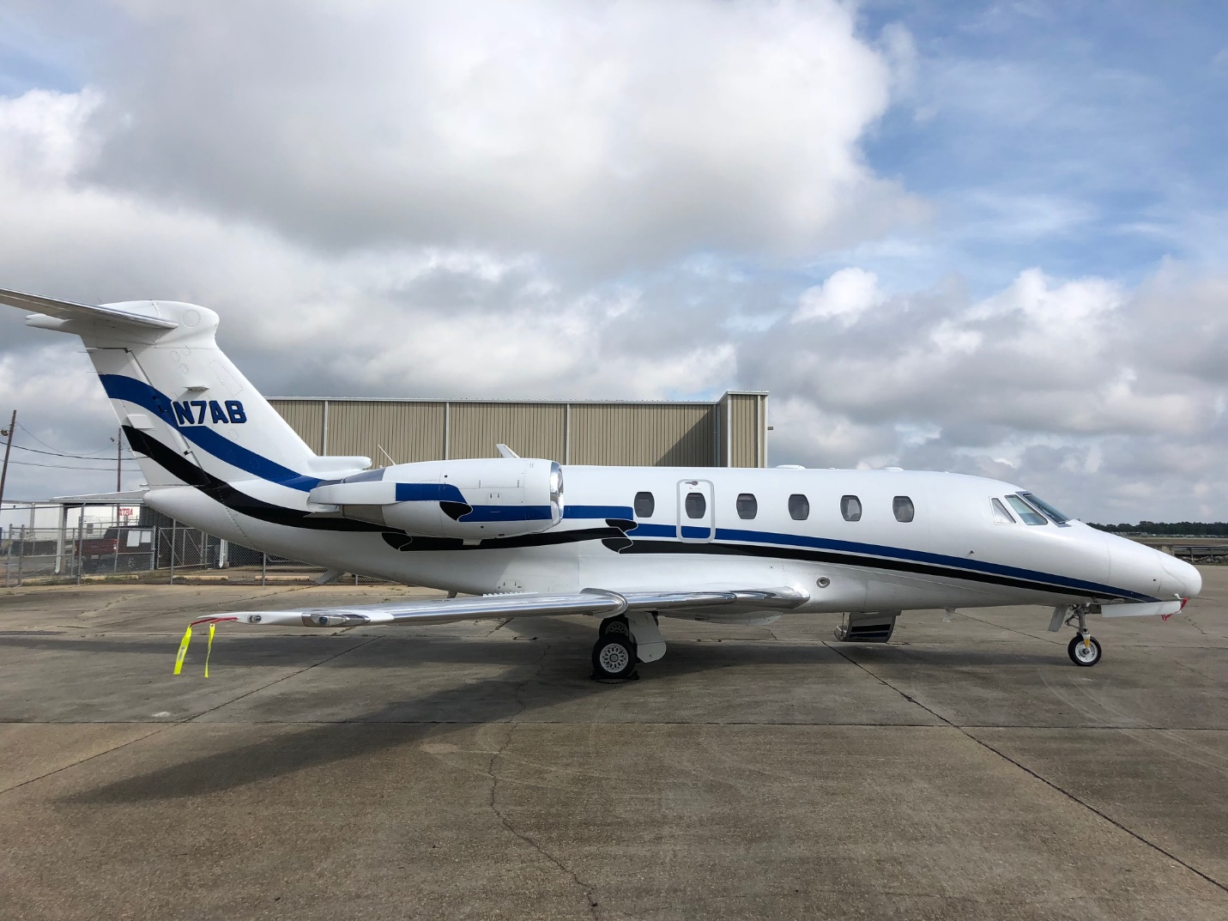

6700TT and 6450 Landings

MSP Gold
ADSB
WIFI ATG-5000
New INterior 2015

AVIONICS
ADF: |  | Collins ADF-462
AFIS: |  | AlliedSignal AFIS
Autopilot: |  | Honeywell SPZ-8000 IFCS
Avionics Package: |  | Dual Honeywell SPZ-8000 IFCS/Pro Line II
Communication Radios: |  | Dual Collins VHF-22C
CVR: |  | Fairchild A200S
DME: |  | Dual Collins DME-42
EFIS: |  | Dual Honeywell 5-tube
Flight Director: |  | Dual Honeywell SPZ-8000 IFCS
Flight Phone: |  | Dual AirCell
FMS: |  | Dual Honeywell FMZ-2000 w/dual GPS
Hi Frequency: |  | Dual King KHF-950 w/SELCAL
Navigation Radios: |  | Dual Collins VIR-32
TAWS: |  | Honeywell Mark VIII EGPWS Class A
TCAS: | Honeywell TCAS-200 TCAS-II
Transponder: | Dual Bendix MST-67A Mode S
Weather Radar: | Honeywell Primus 870 Doppler color
ADDITIONAL EQUIPMENT
Cockpit: | Honeywell Mark VIII Class A EGPWS, dual AirCell SATCOM, multi-function display, ADS-B Out
Crew Accessories: | EROS crew oxygen masks, dual Jeppesen book cases
Equipment: | Automatic power reserve, thrust reversers, engine synch, 76 cubic foot oxygen system, dual 44-amp batteries, aft compartment baggage heater, wemac boost
Lights: | Tail flood, ground recognition, entrance doorstep

INTERIOR
New 2015. ATG 5000 Wifi/ Airshow 400- 9 passenger interior.

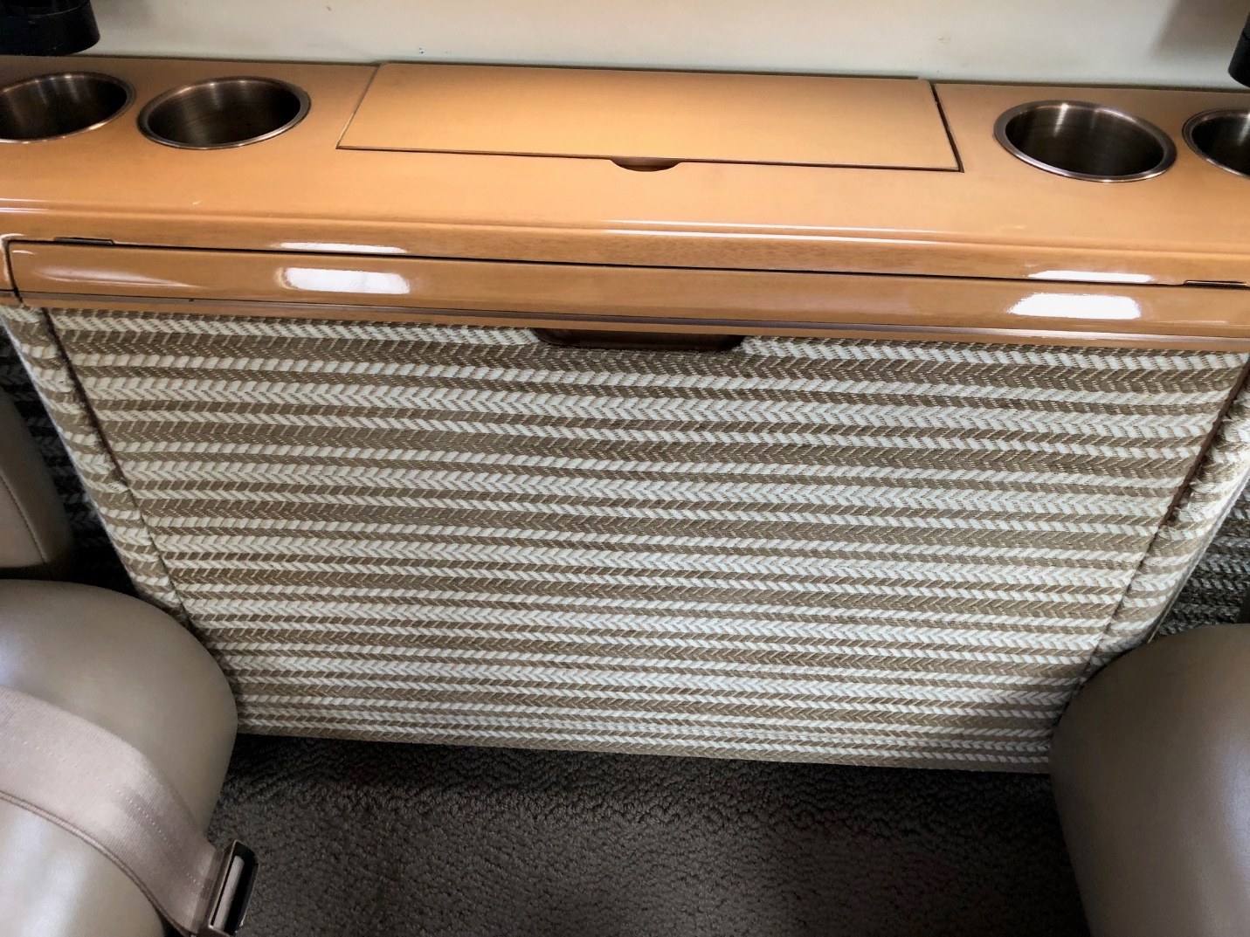
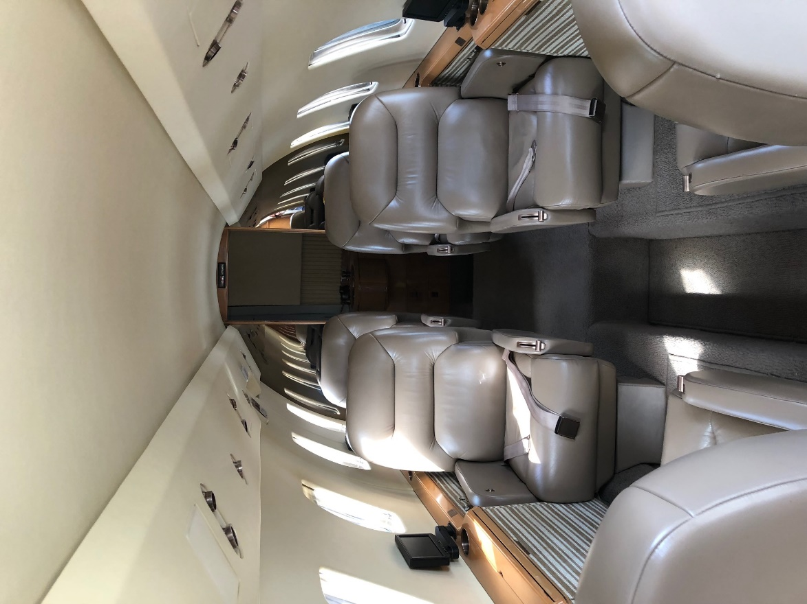
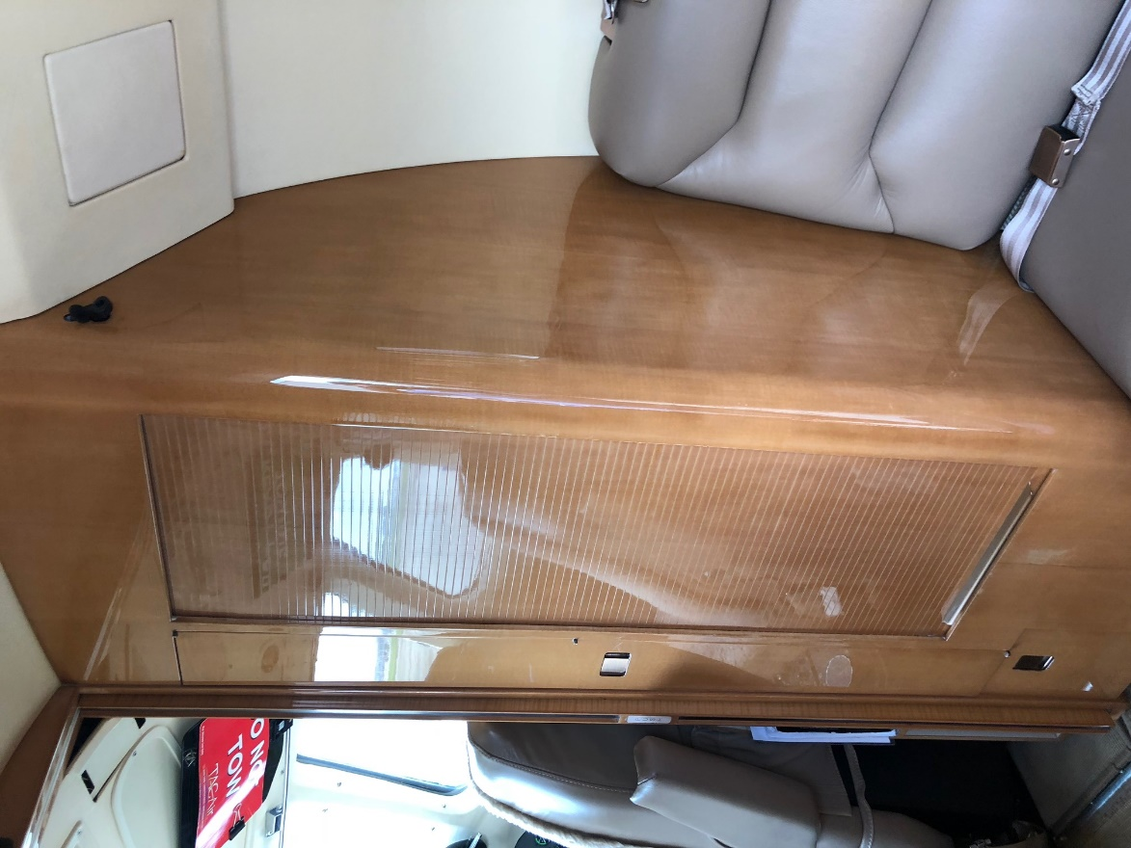
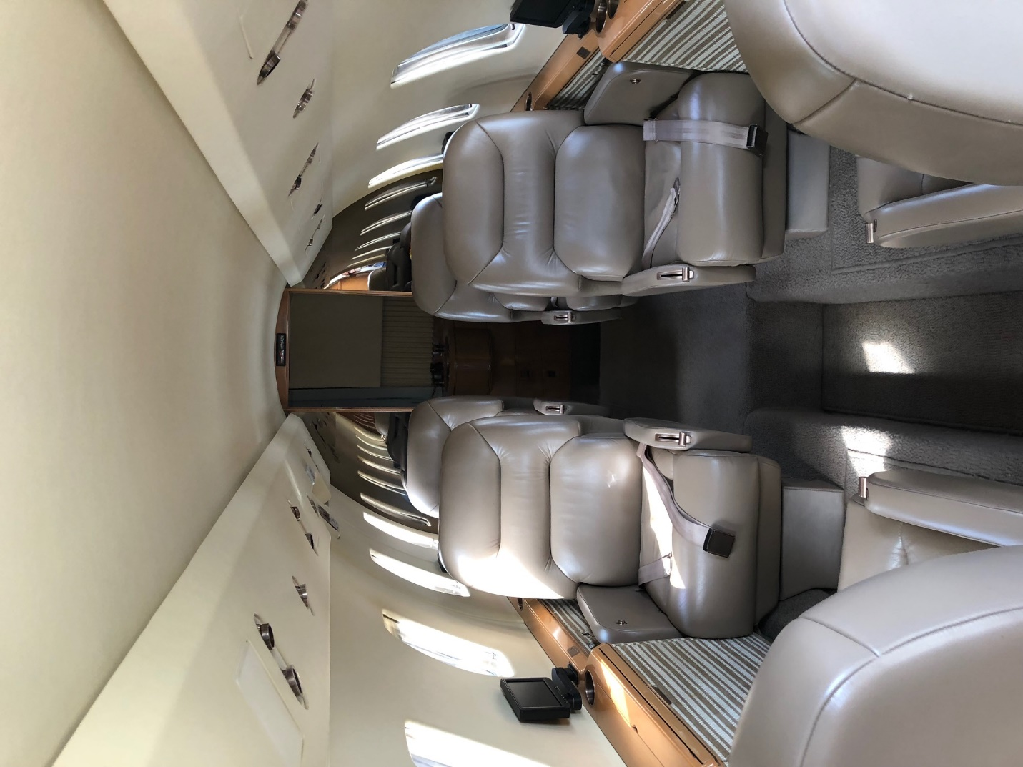
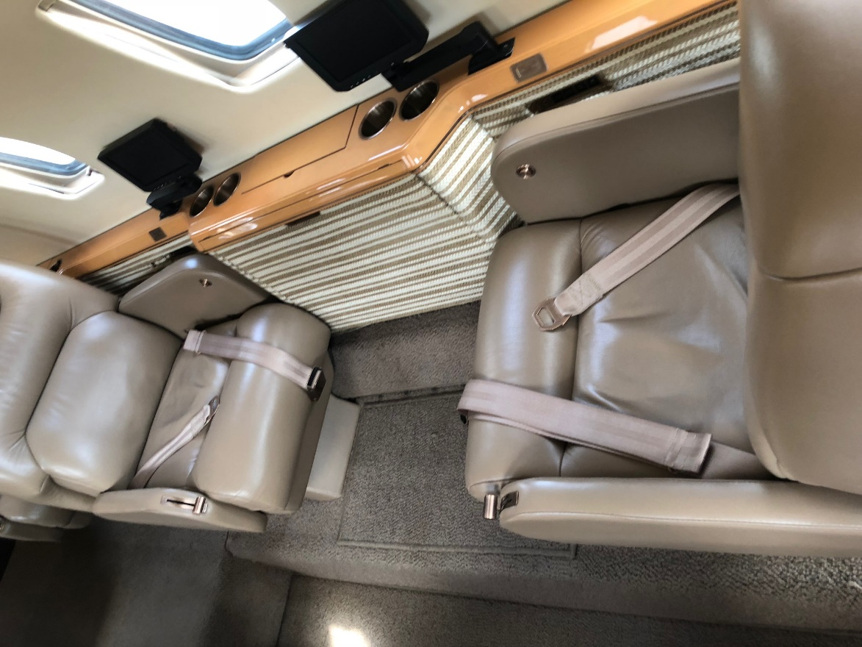
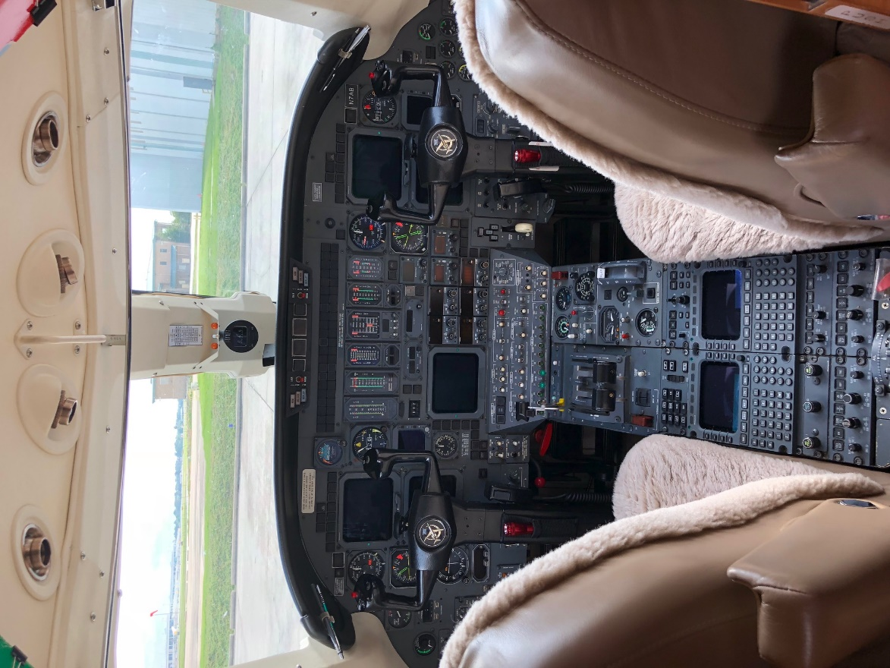

For Specifications and Pricing Call
Tim Palma
317-414-1044 Email:
tim@solutionsaircraft.com

3879 N. Aviation Way, Greenfield, IN 46140
317.414.1044

