Presents
2013 CITATION MUSTANG
MSN 438
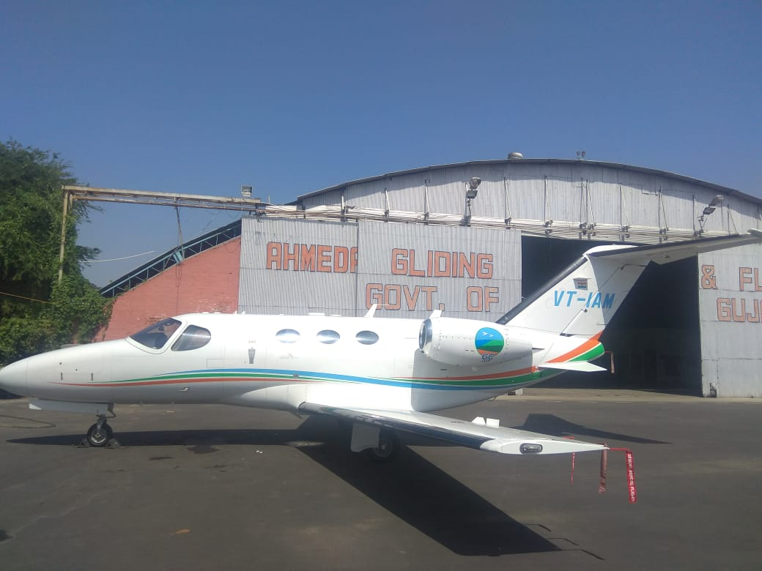
TOTAL TIME: 1280
Engines on Power Advantage Plus
Airframe on Pro Parts
Garmin 1000
High Sierra Edition
Synthetic Vision
WAAS/LPV
TCAS II/ WITH 7.1

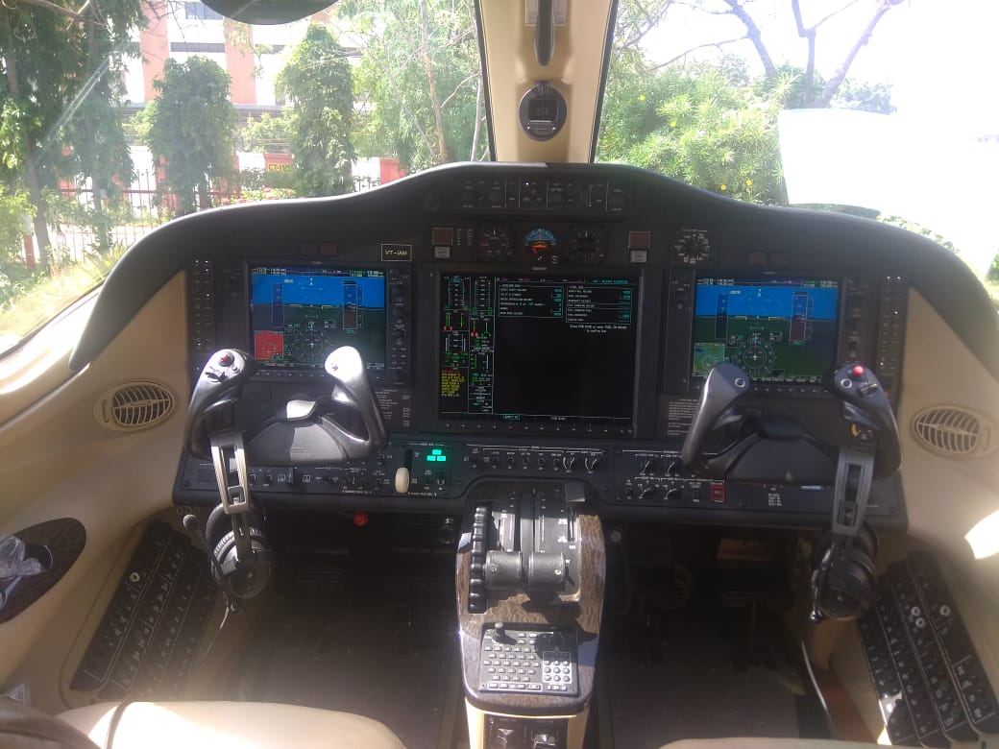
Avionics Installed Garmin 1000
Avionics Details
* 2 PFD + 1 MFD
* FA-2100 CVDR installed with 90 Days ULB Battery
* VHF Transceivers
* GPS Receivers
* ADC
* AHRS
* AFCS
* Dual Mode S Transponders
* Weather Radar
* TAWS
* WAAS/ LPV
* Radio Altimeter
* ADF
* DME
* ILS
* PBN Capable
* RVSM Capable
* Synthetic Vision
* TCAS II W/ 7.1

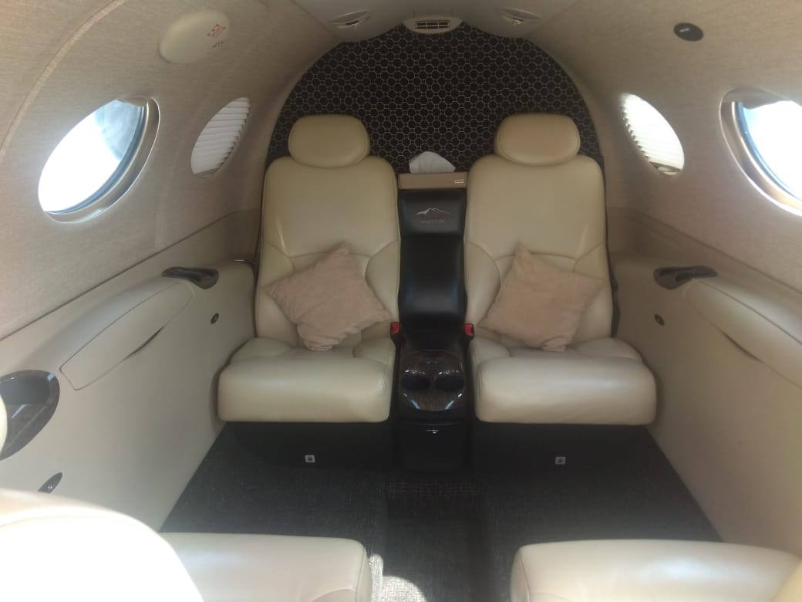
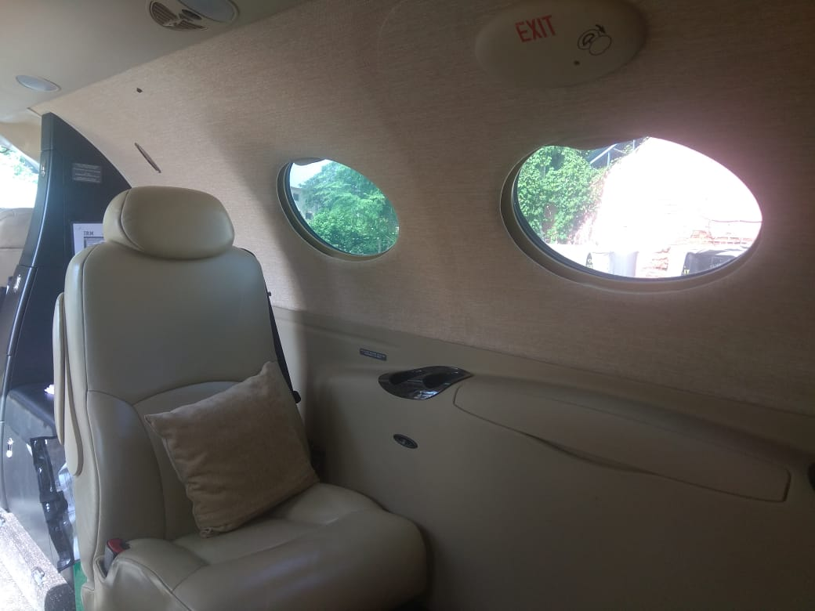

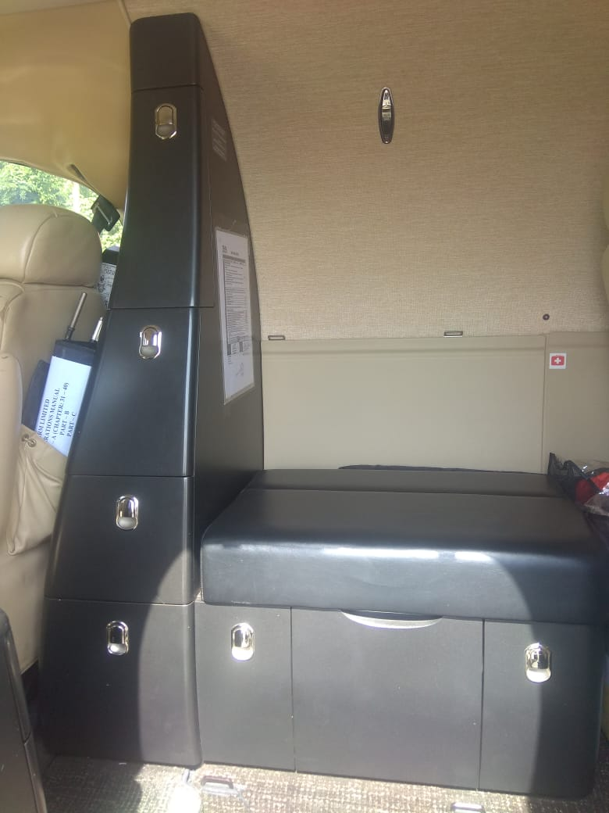

For Specifications and Pricing Call
Tim Palma
317-414-1044 Email:
tim@solutionsaircraft.com

3879 N. Aviation Way, Greenfield, IN 46140
317.414.1044

